SOLUTION HW UNIT 10

1. (b) (i)

|  |
| --- |
| Scatterplot of Tcell by Mass overlaid with the fit line, a 95% confidence band and lower and upper 95% prediction limits. |
| **proc** **glm** data = male plots = all;  model Tcell = Mass / solution;  **run**; |
|  |
|  |

(ii)

|  |  |
| --- | --- |
|  |  |
| **proc** **glm** data = male plots = all;  model Tcell = Mass / solution;  **run**; |  |

(iii) We assume that all the assumptions for a t-test (normal distribution, independent observations) are met.

Ho: 0

Ha: 0

Ho: 0

Ha: 0

Critical Value: 2.093

Test-statistic:

P-value: .0061 < .05

**Conclusion:**

**T**here is sufficient evidence at the alpha = .05 level of significance (P-val = .0061 from t-test) to support that is not equal to 0.

Critical Value: 2.093

Test-statistic:

P-value: .28 > .05

**Conclusion:**

There is not sufficient evidence at the alpha = .05 level of significance (P-val = .28 from t-test) to support that is not equal to 0.

(iv) T-cell response = .03282(Mass) + .0875

(v) **Interpretation of the slope:** For every increase of 1 gram in the mean stone mass, the estimated T-cell response increases by .03282 mm.

**Interpretation of the intercept:** When the mean stone mass is equal to 0, the estimated T-cell response is .0875 mm.

(vi) **Stone mass:** 4.5 g

SE = 0.0338

.2352 ± 2.093(0.0338) **Confidence Interval:** (.1645, .3059)

We are 95% confident that the mean T-cell response when the observed mean stone mass is 4.5 g is between .1645 and .3059 mm.

|  |
| --- |
|  |

(vii)

= .0878

.2352 ± 2.093(.0878)

**Prediction Interval:** (.0515, .4189)

We are 95% confident that the T-cell response when the observed mean stone mass is 4.5 g is between .0515 and .4189 mm.

|  |
| --- |
|  |

(viii)

|  |  |
| --- | --- |
|  | **Mean T-cell Response:**  We are 95% confident that the estimated mass that would be needed to have a mean t-cell response of 0.3 mm is between 4 and 7.5 g.  **Individual T-cell Response:**  We are 95% confident that the estimated mass that would be needed to have a t-cell response of 0.3 mm is between 1.5 and 11.5 g. |
| **Calculation in R is slightly different than that of the method described below and more exact than the visual method of course. Needs the investr package.**  **Additional reference: https://journal.r-project.org/archive/2014-1/greenwell-kabban.pdf** | |

SE(

6.475

(1.163, 11.787)

(ix) **Mean of T-cell response:**

SE(

We are 95% Confident that the estimated mass that would be needed to have a t-cell response of 0.3 mm is between 1.163 and 11.787g.

We are 95% Confident that the estimated mass that would be needed to have mean t-cell response of 0.3 mm is between 5.244 and 7.706 g.

.3 = .03282(Mass) + .0875

Mass =

(5.244, 7.706)

(x)

|  |  |
| --- | --- |
|  |  |
| **proc** **glm** data = male plots = all;  model Tcell = Mass / solution;  **run**; |  |
| Additional Resource:  https://www.r-bloggers.com/visualising-residuals/ | |

(xi)

|  |  |
| --- | --- |
| Panel of fit diagnostics for Tcell. |  |
| **proc** **glm** data = male plots = all;  model Tcell = Mass / solution;  **run**; |  |

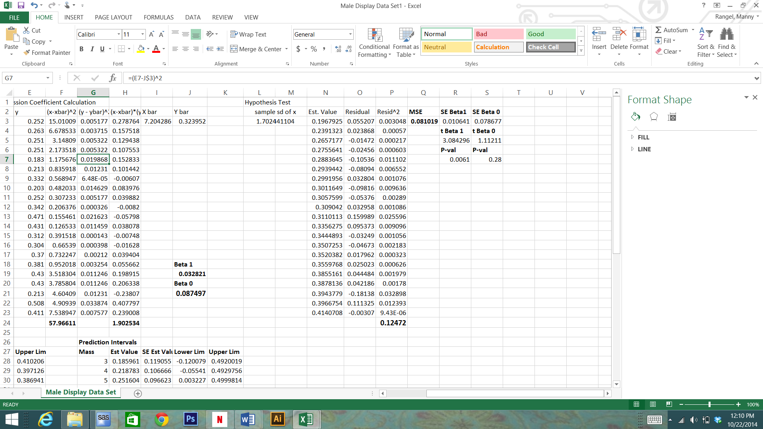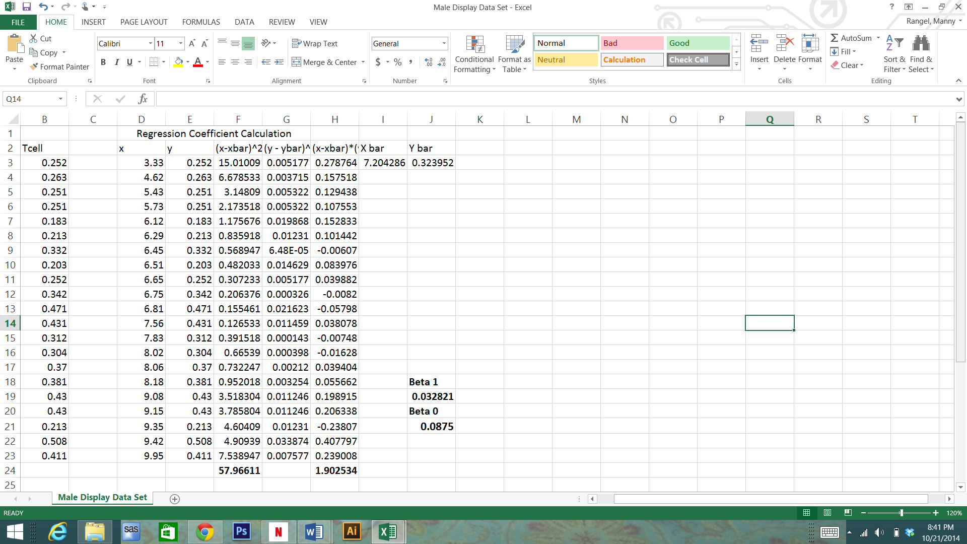2. (a) (b)

|  |  |
| --- | --- |
|  |  |

(c) above (d) above

(e) Graphical Method:

|  |  |
| --- | --- |
|  | **Mean of T-cell Response:**  We are 95% confident that the estimated mass that would be needed to have a mean t-cell response of 0.3 mm is between 4.5 and 7.6 g.  **Individual T-cell Response:**  We are 95% confident that the estimated mass that would be needed to have a t-cell response of 0.3 mm is between 1.5 and 11.5 g (visual estimation … answers will vary.) |

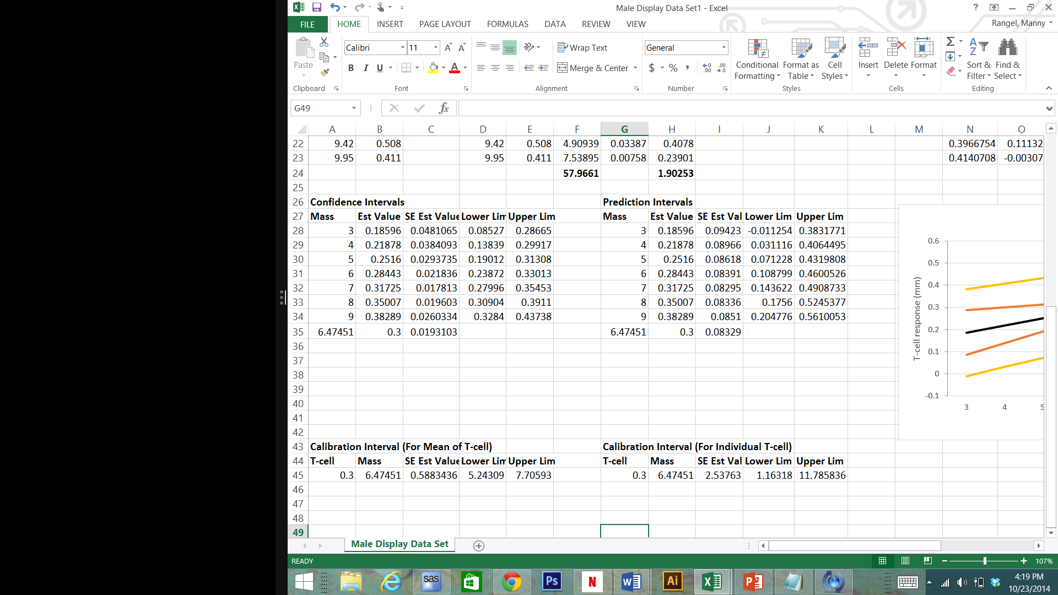Analytical Method:

Mean of T-cell Response:

We are 95% confident that the estimated mass that would be needed to have a mean t-cell response of 0.3 mm is between 5.243 and 7.706 g.

Individual T-cell Response:

We are 95% confident that the estimated mass that would be needed to have a t-cell response of 0.3 mm is between 1.163 and 11.786 g.

(f)

3. (i)

|  |
| --- |
| Scatterplot of OverEstimate by Distance overlaid with the fit line, a 95% confidence band and lower and upper 95% prediction limits. |
| **data** vote;  input OverEstimate Distance;  datalines;  5.3 0  6.4 5  5.6 17  7.6 37  9.6 75  12.3 100  ;  **proc** **glm** data = vote;  model OverEstimate = Distance;  **run**; |
|  |
|  |

(ii)

|  |  |
| --- | --- |
|  |  |
| **proc** **glm** data = vote;  model OverEstimate = Distance / solution;  **run**; |  |

(iii) We assume that all the assumptions for a t-test (normal distribution, independent observations) are met.

Ho: 0

Ha: 0

Critical Value: 2.132

Test-statistic:

P-value: .0002 < .05

**Conclusion:**

**T**here is sufficient evidence at the alpha = .05 level of significance (P-val = .0010 from t-test) to support that is not equal to 0.

Ho: 0

Ha: 0

Critical Value: 2.132

Test-statistic:

P-value: .0002 < .05

**Conclusion:**

**T**here is sufficient evidence at the alpha = .05 level of significance (P-val = .0002 from t-test) to support that is not equal to 0.

(iv) Overestimate = 5.258 + .06517(Distance)

(v) For every 1 unit increase in the distance to the interviewer from the door, the overestimate increases by .06517.

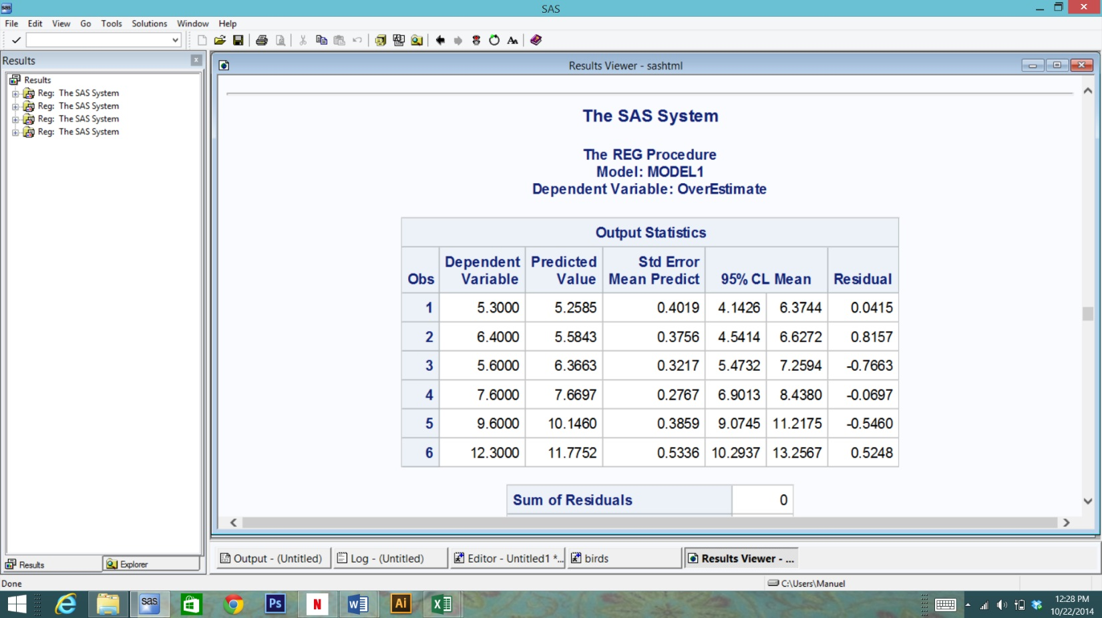When the distance to the interviewer from the door is 0 units, the overestimate is 5.258.

SE = 0.2767

7.6697 ± 2.776(0.2767) **Confidence Interval:** (6.9013, 8.438)

(vi) **Distance :** 37

**Confidence Interval:** (6.9013, 8.438)

We are 95% confident that the mean overestimate when the observed distance to the interviewer from the door is 37 units is between 6.9013and 8.438.

|  |
| --- |
|  |

(vii) **Distance:** 37

= .731

7.6697 ± 2.776(0.731)

**Prediction Interval:** (5.64, 9.700)

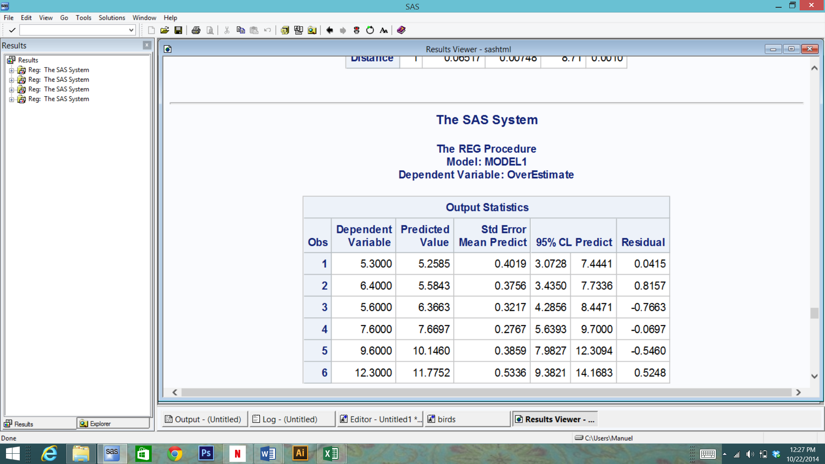

**Prediction Interval:** (5.6393, 9.7)

We are 95% confident that the overestimate when the observed distance to the interviewer from the door is 37 units is between 5.6393and 9.7.

|  |
| --- |
|  |

(viii)

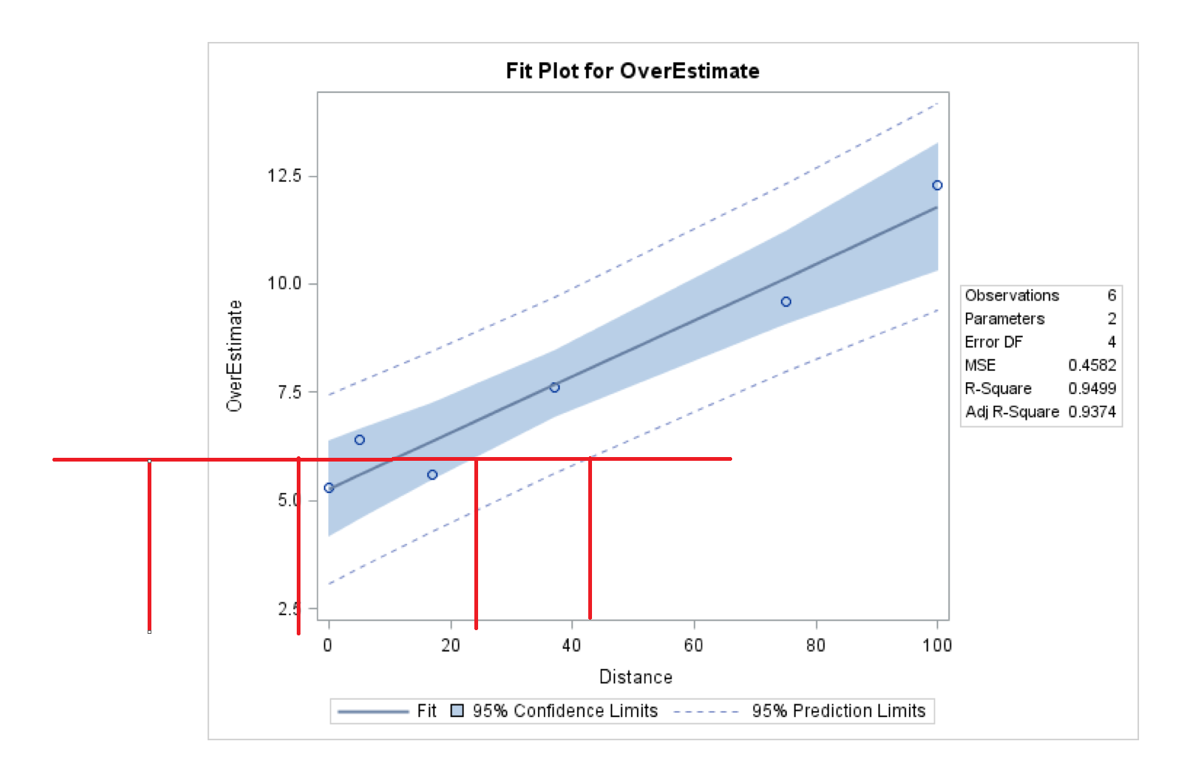

Mean of Overestimate:

We are 95% confident that the estimated distance that would be needed to have a mean overestimate of 6 points is between -5 and 25 ft.

Individual Overestimate:

We are 95% confident that the estimated distance that would be needed to have an overestimate of 6 points is between -13 and 45 ft.

|  |
| --- |
|  |

(ix) Mean of Overestimate: Individual Overestimate:

6 = .06517(Distance) + 5.258

Distance =

(-.2676, 23.0396)

We are 95% confident that the estimated distance that would be needed to have a mean overestimate of 6 points is between -.2676and 23.0396ft.

6 = .06517(Distance) + 5.258

Distance =

(-19.799, 42.571)

We are 95% confident that the estimated distance that would be needed to have an overestimate of 6 points is between (-19.799and 42.571ft.

(x)

|  |  |
| --- | --- |
| Scatter plot of residuals by Distance for OverEstimate. |  |
| **proc** **glm** data = vote plots = all;  model OverEstimate = Distance / solution;  **run**; |  |

(xi)

|  |  |
| --- | --- |
| Panel of fit diagnostics for OverEstimate. |  |
| **proc** **glm** data = vote plots = all;  model OverEstimate = Distance / solution;  **run**; |  |

(b) The evidence that the mean Kerry overestimate increases with increasing distance of the interviewer from the door is strong because r2 = 95%. Therefore, about 95% of the variation in overestimate is explained by the distance of the interviewer from the door.

Bonus:

The unit of distance that was used was feet.

5.

**Wheatear Data:**

About r2 = 36% of the variation in t-cell response is explained by the mass of the stone. Leaving 64% for the other factors combined.

**Sample Bias Data:**

About r2 = 95% of the variation in overestimate is explained by the distance of the interviewer from the door. Leaving 5% for the other factors combined.

2

= 2)

=

=

=

= 0

= 0

=

=

(